Standard operating procedure
The Rosie Hospital Maternal Medicine Centre (MMC) external referral pathway
Audit Standards
- Pregnant women with a medical condition as defined in section 4 will be referred to the Maternal Medicine Centre (MMC) via email: add-tr.rosie-maternalmedicine@nhs.net
- Email referrals to the MMC will be reviewed within 5 working days.

Scope
This SOP is for use by GPs and consultants referring from other hospitals (external referrals), mainly but not exclusively from the East of England region.
It is not intended as a referral pathway for women choosing to book within Cambridge University Hospitals NHS Foundation Trust (CUH) who should be referred using the standard referral pathways, please see: Antenatal risk assessment and criteria for referral for obstetric-led care (or obstetric opinion) by midwives and Maternal Medicine SOP.

Purpose
To provide a simple, clear pathway for referral of women pregnant with a pre-existing medical problem or an acute medical complication of pregnancy.

Definitions
CUH  ED  MBRRACE | Cambridge University Hospitals NHS Foundation Trust  Emergency Department  Mothers and Babies: Reducing Risk through Audits and Confidential Enquiries across the UK
MDT | Multidisciplinary team
MMC | Maternal Medicine Centre
UK | United Kingdom

The Maternal Medicine Network MDT refers to the multidisciplinary team (MDT) at the Rosie, including named Consultant, specialist anaesthetists, specialist registrars and specialist midwives.

Introduction
Maternal medicine is the specialist care of pregnant women with either pre-existing medical disease or who have specific pregnancy related diseases that can affect any organ in the body:
- Hyperemesis gravidarum
- Hypertension in pregnancy
- Pre-eclampsia
- Kidney disease in pregnancy
- Vasculitic disease in pregnancy
- Neurological disease in pregnancy
- Liver disease in pregnancy
- Endocrine disorders in pregnancy
- Cancer
- Heart disease
- Joint and connective tissue disorders
- Lung/respiratory disease
- Liver and metabolic disorders
- Haematological/blood disorders including sickle cell disease, thrombosis and coagulation problems.

It also includes acute illness where the underlying condition is not clear, such as:
- Headache
- Breathlessness
- Chest pain
- Abdominal pain
- Fever/sepsis

The incidence of maternal deaths from indirect causes is not falling in the UK at the same rate as direct deaths. 68% of women dying in the most recent MBRRACE-UK (2021) report had medical co-morbidities (excluding obesity) and in 41% of cases, assessment identified improvements to care which may have made a difference to the outcome. Maternal medical conditions are also significantly associated with neonatal morbidity and mortality.

The formation of a maternal medicine network, as recommended in Safer Maternity Care (DoH, 2017) aims to deliver co-ordinated and specialist care for women in the region with complex medical conditions.

The maternal medicine network is made up of:

- Maternal medicine centre (hub)
- Local maternity centres (spokes)

The Rosie Hospital is one of two designated MMCs in the East of England and will receive referrals from the network’s spokes. Norfolk & Norwich University Hospitals NHS Foundation Trust are the region’s second MMC.

When a woman is referred to the MMC, a number of options are available:
- Advice and Guidance without review
- Review, offer advice regarding pregnancy care and delivery and then referral back to local unit
- Share care with local unit and MMC (may recommend delivery in local unit or MMC)
- MMC to take over obstetric care

Responsibilities
As an MMC the Rosie will provide regional clinical leadership on the identification, referral and management of women with medical conditions, including co-developing guidelines and referral pathways. In addition the MMC will ensure that appropriate education is in place across the network for all clinicians – i.e. midwives, obstetricians, GPs and emergency department (ED) staff – to improve local identification and referral of acute issues that have particular significance in women who are or have recently been pregnant.

The MMC will work alongside the specialist MDT to provide advice and care for the most complex/high risk women, along with system-wide leadership and education.

Referral pathway
All routine referrals for both pre-pregnancy counselling and confirmed pregnancies must be sent to the Rosie MMC email (add-tr.rosie-maternalmedicine@nhs.net) using the form attached in appendix 1. Routine referrals will be dealt with within 5 working days. Referrers will be informed of the initial outcome by email. A letter will be sent to the referrer either with advice and guidance or after the woman is seen either virtually or face to face.

Attached (appendix 2) is the referral guideline for Networked Maternal Medicine Services in the East of England. It is anticipated this will help inform decisions regarding routine referrals to the MMC.

Urgent or emergency referrals should continue to be discussed with the on-call Obstetric Consultant via CUH switchboard (01223 245151).

References
DoH, 2007. Maternity Matters: Choice, access and continuity of care in a safe service. Department of Health, London. Available at: https://dera.ioe.ac.uk/9429/7/dh_074199_Redacted.pdf
DoH, 2017. Safer Maternity Care. Department of Health, London. Available at: https://www.gov.uk/government/publications/safer-maternity-care-progress-and-next-steps
MBRRACE-UK, 2021. Saving Lives, Improving Mothers’ Care – Lessons learned to inform maternity care from the UK and Ireland Confidential Enquiries into Maternal Deaths and Morbidity 2017-19. Available at: https://www.npeu.ox.ac.uk/mbrrace-uk/reports
National Health Service, 2021. Maternal Medicine Network Service Specification. Available at: https://www.england.nhs.uk/publication/maternal-medicine-networks-service-specification/
National Maternity Review, 2016. Better Births: Improving outcomes of maternity services in England: A five year forward view for maternity care. Available at: https://www.england.nhs.uk/wp-content/uploads/2016/02/national-maternity-review-report.pdf
Ockenden, 2020. Emerging Findings and Recommendations from the Independent Review of Maternity Services at the Shrewsbury and Telford Hospital NHS Trust. Available at: https://www.donnaockenden.com/downloads/news/2020/12/ockenden-report.pdf
RCOG, 2016. Patterns of maternity care in English NHS trusts 2013/14.
Equality and diversity statement

This document complies with the Cambridge University Hospitals NHS Foundation Trust service equality and diversity statement.
Disclaimer

It is your responsibility to check against the electronic library that this printed out copy is the most recent issue of this document.

Document management

Document control/change history
Issue | Author (s) | Owner | Date | Circulation | Comments
Version 1 | Charlotte Patient (Consultant),  Catherine Aiken (Consultant) and  Catherine Barlow (Lead Midwife for High-risk care) | Maternity Services | 21 April 2022 | Kimberley Skinner, Lead Midwife for Quality and Patient Experience; Emma Rose, Safety & Quality Implementation Midwife; Perinatal Business Meeting circulation. | New document to implement Maternal Medicine Centre Explicit mention of early specialist involvement.

Approval: | Perinatal Business Meeting 21 April 2022
JDTC approval: | N/A
Owning department: | Maternal medicine
Author(s): | Charlotte Patient (Consultant)  Catherine Aiken (Consultant)  Catherine Barlow (Lead Midwife for High-risk care)
Pharmacist: | N/A
File name: | Maternal medicine external SOP (v1 approved Apr 22)0000.doc
Supersedes: | n/a (new document)
Version number: | 1 | Review date:
Local reference: |  | Document ID:

Appendix 1: External referral form
Maternal Medicine Department
Rosie Hospital
Cambridge University Hospitals NHS Foundation Trust
Hills Road, Cambridge
CB2 2QQ

Phone: via CUH Switch 01223 805000 Email: add-tr.rosie-maternalmedicine@nhs.net
BLOCK CAPITALS PLEASE

REFERRING UNIT DETAILS

Referral Date: Consultant:

Referring Hospital: Referring Dept:

Contact No:

PATIENT CONTACT DETAILS

Full Name: DoB:

NHS number:

Address:

Postcode:

Contact Nos:

GP Name & Address:

Phone No:

Referral for Review

ADVICe and GUIdance ONLy

DETAILS OF THIS PREGNANCY

EDD: Parity: Gestation:

Medical Diagnosis:
Current Medication :
Physician in charge of care: ………………………………………..
Hospital if different from above: ……………………………..

If any problems in previous pregnancies please give details:

REASON FOR REFERRAL REQUEST

Appendix 2: Networked Maternal Medicine Services in the East of England

Introduction
This document has been written to support clinicians (obstetricians, anaesthetists, primary care doctors) to access tertiary maternal medicine services throughout the East of England.

Background
Maternal death from indirect causes is not falling in the UK at the same rate as direct deaths. 66% of women dying in the most recent MBRRACE-UK report had medical co-morbidities (excluding obesity) and in 41% of cases, assessment identified improvements to care which may have made a difference to the outcome. Maternal medical conditions are also significantly associated with neonatal morbidity and mortality.
The formation of a maternal medicine network, as recommended by Department of Health in Safer Maternity Care, aims to deliver coordinated and specialist care for women in the region with complex medical conditions. The network approach to delivering care has been embraced by many specialties of medicine, surgery and within maternity for fetal medicine services, and is already practiced in an ad-hoc way for medical problems in the maternity population.
The Ockenden Report has an essential recommendation that ‘Through the development of links with the tertiary level Maternal Medicine Centre there must be agreement reached on the criteria for those cases to be discussed and/or referred to a maternal medicine specialist centre.’

The East of England maternal medicine network is made up of:
- Maternal medicine centres (hub)

- Local maternity units (spoke)

In the East of England due to the wide geographical area we cover, there will be hubs in Norwich and Cambridge. Some women may choose to have their care in other centres such as London, Leicester, and Nottingham. This document offers guidance in the management of women with underlying medical conditions in pregnancy.

Along with the development of the network and regional referral guidelines it would also be expected that each unit would have local guidelines for the following conditions as a minimum.

- Epilepsy

- Hypertension in pregnancy including pre-eclampsia

- Diabetes mellitus (T1, T2, GDM)

- Bleeding disorders e.g., Haemophilia, thrombocytopenia

- Heart disease

- Acute VTE

- Prevention of VTE

- Sickle cell disease

Local units will also need to provide some pre-pregnancy counselling in conjunction with primary care and the network hubs.

National guidelines are available either from the RCOG or NICE for all these conditions.

Use of these referral guidelines

These guidelines are intended for use by anyone considering referring patients to a maternal medicine centre either during pregnancy or for pre-pregnancy counselling. This is likely to be obstetricians at local maternity units, but may also include specialist midwives, obstetric anaesthetists, and other relevant professionals.

The referral guidelines below do not replace local pathways for medical conditions in pregnancy and should always be considered in the context of the services and expertise available in each local unit.

It is recommended that women with any category C condition below should be referred to a maternal medicine centre for pre-pregnancy counselling if possible, but otherwise referred early in pregnancy. Women with category B conditions may also benefit from pre-pregnancy counselling, either locally or in a maternal medicine centre.

Referral may not always involve women travelling to be seen in person at the maternal medicine centre. For category B conditions a range of management options may be appropriate, including for example advice and guidance only via email, telephone/video antenatal appointments, or in person review.

A referral to the maternal medicine centre is appropriate in any condition where clinical expertise is not available in the local maternity unit

Referral Guidelines for Medical Conditions in Pregnancy

Depending on the complexity of the condition in pregnancy, at the time of delivery and in the post-partum period, the relative contribution of the maternal medicine hub and local maternity centres may change.

Medical conditions are classified as category A, B or C, depending on complexity:

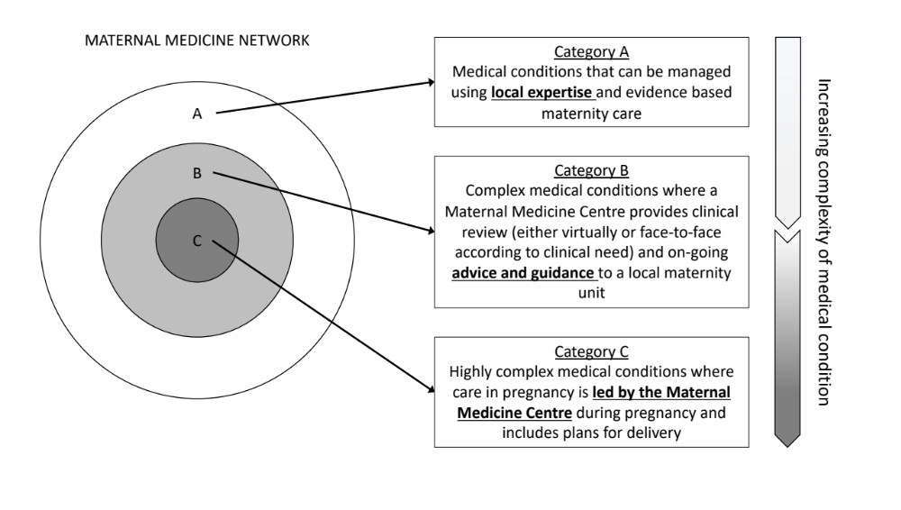
These categories are a guide only, are not intended as a barrier to referral and discussion about any woman is welcomed by any clinician as needed. They can be modified according to local expertise and experience. Where local expertise is sufficient, a condition may move from category C to B, or B to A. Where local expertise is insufficient, when a condition progresses or increases in severity during pregnancy, or when there is clinical concern, a condition should move from category A to B, or B to C:

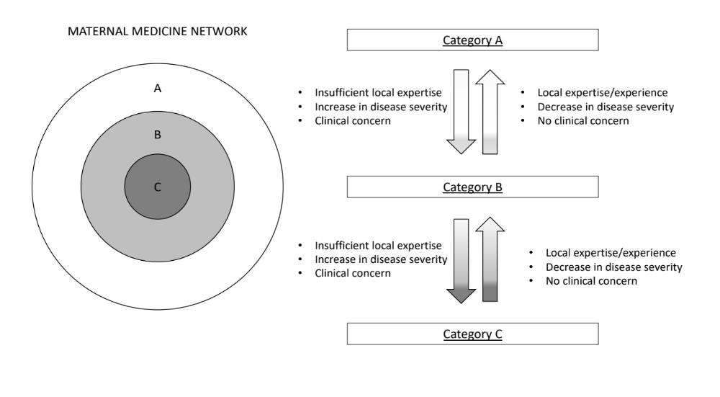

Renal Disease

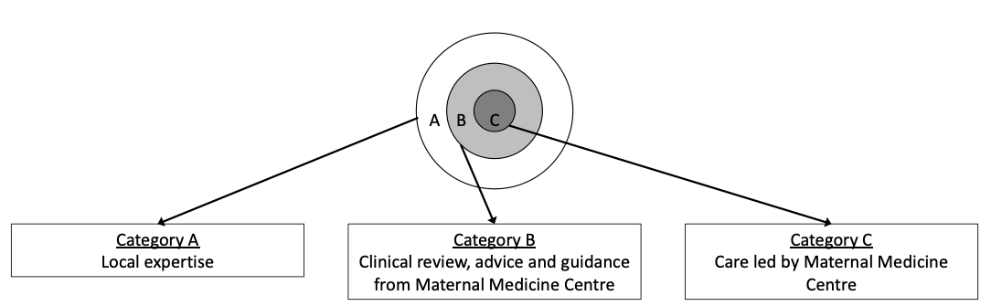

Category A | Category B | Category C
Stable CKD1/2 | CKD 3/4 | CKD4/5 (on or off dialysis)
Single kidney | Kidney Transplant | Kidney-pancreas transplant
Reflux nephropathy (uncomplicated) | Proteinuria due to pre-existing renal disease (PCR up to 350mg/mmol) | Proteinuria due to pre-existing renal disease (PCR > 350)
Previous pregnancy complicated by pre-eclampsia | Hypertension on more than 1 agent | Active glomerular disease e.g. lupus nephritis
Renal stone disease | Glomerulonephritis on immunotherapy
Recurrent UTI | Previous pregnancy complicated by AKI stage 3 (creatinine >x3 baseline) or HELLP syndrome
 | Gitelman syndrome

Respiratory Disease

Category A | Category B | Category C
Asthma | Restrictive Lung Disease (e.g ILD, Kyphoscoliosis) with FVC <50% expected | Cystic Fibrosis
Sarcoidosis | Any lung disease on immunotherapy | Lung transplant
 | Asthma with recent hospitals admissions
 | Recent or active Tuberculosis (TB)

Gastrointestinal Disease

Category A | Category B | Category C
Hyperemesis gravidarum | Complex Inflammatory bowel disease: active disease despite treatment; on biologic therapy; peri-anal disease; previous complex surgery | Portal Hypertension (any degree)
Constipation | Pancreatitis | Complex pancreatitis – ongoing clinical impact / treatments.
Gallstones | Treated GI malignancy | Liver transplant
Gastro-oesophageal reflux | Unexplained jaundice
Coeliac disease | Previous Acute Fatty Liver of Pregnancy.
Viral hepatitis | Achalasia
Intra-hepatic cholestasis of pregnancy | Auto-immune hepatitis
Uncomplicated Inflammatory bowel disease in remission (and not on biologic immunotherapy)

AVAILABLE CLINICAL GUIDANCE:

British Society of Gastroenterology consensus guidelines on the management of inflammatory bowel disease in adults | Gut (bmj.com)

Standards for the provision of antenatal care for patients with inflammatory bowel disease: guidance endorsed by the British Society of Gastroenterology and the British Maternal and Fetal Medicine Society (bsg.org.uk)

Neurological Disease
Category A | Category B | Category C
Uncomplicated Epilepsy on AEDs | Epilepsy on 2 or more AEDs or unstable clinical course | Myasthenia gravis
Stable Multiple Sclerosis (MS) | MS on Immunotherapy | Untreated cerebral aneurysm
Migraine and headache | Previous history of: stroke, intracranial haemorrhage, treated or risk cerebral aneurysm
Uncomplicated Idiopathic intracranial hypertension (IIH) | VP shunts, reservoirs
 | Arnold-Chiari malformations

Endocrinology
Category A | Category B | Category C
Hypothyroidism/treated hyperthyroidism | Thyrotoxicosis | Phaeochromocytoma
Hypoparathyroidism | Active hyperparathyroidism with hypercalcaemia | Active / new diagnosis of thyroid cancer
Uncomplicated pre-existing diabetes | Adrenal tumours | Diabetes insipidus
Gestational diabetes | Pre-existing diabetes with significant renal impairment or autonomic neuropathy | Macroprolactinoma
Microprolactinoma

Rheumatological Disease
Category A | Category B | Category C
Uncomplicated Rheumatoid | Any connective tissue disease with extra-articular manifestations involving heart, kidneys or lungs. | Ehlers-Danlos type IV (vascular phenotype)
Uncomplicated SLE | Bechet’s disease | Scleroderma
Ehlers-Danlos T 1-3 / hypermobility syndrome. | Antiphospholipid syndrome (APLS) – with previous VTE.
 | Vasculitis (stable) on treatment | Active vasculitis / frequently relapsing vasculitis

Haematology
Category A | Category B | Category C
Iron deficiency anaemia | Beta thalassemia | Sickle cell disease
Pernicious anaemia | VTE in current pregnancy < 4 weeks before EDD | Previous or current HUS or TTP
Gestational thrombocytopaenia | Haemophilia carrier | Von Willebrand disease
G6PD | Aplastic anaemia | Metallic heart valves on anticoagulation (see CARDIAC)
 | Previous VTE on long-term warfarin
 | Immune thrombocytopaenia
 | Platelet function disorders

Metabolic Disease / Infectious Disease/Oncology
Category A | Category B | Category C
Familial hypercholesterolaemia | Malaria in current pregnancy | Phenylketonuria, Glycogen storage disease, Galactosemia, Fatty acid oxidation defects, Inherited hypophosphatemia. Lysosomal storage disorders
HIV disease on treatment | Previous lymphoma/leukaemia | Newly diagnosed or active cancer
Treated breast/thyroid/melanoma | Previous abdominal or pelvic malignancy
Treated benign CNS lesions

Cardiac Disease
Category A | Category B | Category C
Isolated mild valve disease without symptoms and otherwise normal echo (excluding mitral stenosis) | Dilated cardiomyopathy with left ventricular ejection fraction >45% | Pulmonary hypertension
Small/repaired patent ductus arteriosus. | Hypertrophic cardiomyopathy with no high-risk features | Left ventricular ejection fraction <45%
Mitral valve prolapse with no significant mitral regurgitation | Repaired aortic coarctation | Moderate/severe mitral stenosis
Repaired atrial or ventricular septal defect with normal echo and no dysrhythmia | Mild mitral stenosis | Severe aortic stenosis
 | Moderate aortic stenosis | Systemic right ventricle
Isolated atrial or ventricular ectopic beats | Atrioventricular septal defect | Fontan circulation
Ablated WPW and no persisting dysrhythmia | Repaired tetralogy of Fallot | Ventricular arrhythmia
 | Supraventricular arrhythmias | Mechanical valve
 | Turner syndrome without aortic dilatation | Vascular Ehlers Danlos
 | Repaired atrial or ventricular septal defect with persisting echo abnormalities or arrhythmia | Aortopathy (including Marfan’s, Loeys-Diez)/previous dissection
 | Unrepaired ASD or VSD
 | Previous peripartum cardiomyopathy
 | Moderate valvular regurgitation
 | Bicuspid aortic valve
 | Ischaemic heart disease
 | Permanent pacemaker
 | First degree relative with sudden unexplained cardiac death <40y

AVAILABLE CLINICAL GUIDANCE:
ESC Guidelines on the management of cardiovascular diseases during pregnancy: The Task Force on the Management of Cardiovascular Diseases during Pregnancy of the European Society of Cardiology

ESC Guidelines on the management of cardiovascular diseases during pregnancy | European Heart Journal | Oxford Academic (oup.com)

https://www.npeu.ox.ac.uk/assets/downloads/mbrrace-uk/reports/perinatal-report-2020-twins/MBRRACE-UK_Twin_Pregnancies_Confidential_Enquiry.pdf
https://assets.publishing.service.gov.uk/government/uploads/system/uploads/attachment_data/file/662969/Safer_maternity_care_-_progress_and_next_steps.pdf
https://www.donnaockenden.com/downloads/news/2020/12/ockenden-report.pdf

