ADDENBROOKE’S HOSPITAL PHYSIOTHERAPY SELF-REFERRAL FORM FOR THE PREGNANCY-RELATED PELVIC GIRDLE PAIN (PGP) VIRTUAL CLASS

For patients registered with a GP

Please complete ALL questions and email this referral form to: add-tr.pelvichealth.physiotherapy@nhs.net
Putting ‘Referral to PGP Class’ in the subject line

Alternatively, you may post your completed form to:
PGP Class, Pelvic Health & Obstetric Physiotherapists, Outpatient Physiotherapy Department PO Box 185, Addenbrooke's Hospital, Hills Road, Cambridge CB2 0QQ

Your referral will be assessed by a physiotherapist and you will be contacted to invite you to the next available PGP class.
We are unable to accept referrals for those under the age of 16.
Please note that the class is unsuitable for anyone requiring an interpreter – please complete the standard physiotherapy self-referral form instead, stating that you need an interpreter.

Full Name: Date of Birth

Daytime phone no: Mobile no:

Are you happy for us to leave an answer phone message? YES/ NO

Address: GP:

Surgery:

Hospital/NHS Number (if known):

Postcode: Occupation:

Obstetrician/Midwifery Team: Expected Date of Delivery:

How long have you had the current problem?

Have you consulted your GP or Midwife about this problem? YES/NO Are you signed off sick for this problem? YES/NO
Have you had this problem before? YES/NO

Have you received any physiotherapy for this problem YES/NO

Your pregnancy:

Is this your first pregnancy? YES/NO

Do you have a history of miscarriage? YES/NO

How many weeks pregnant are you?

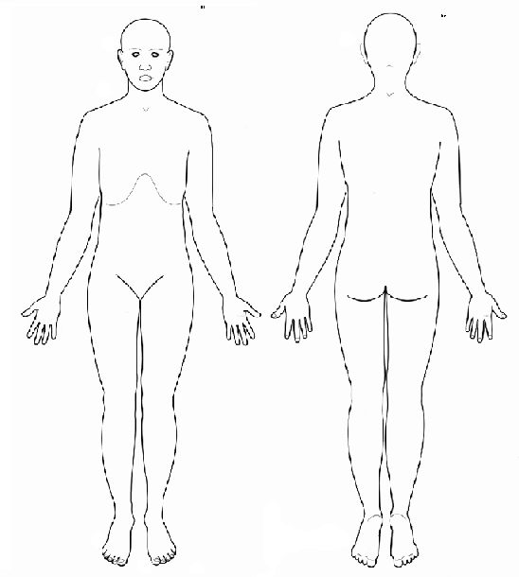Are there any other problems with this pregnancy?
Please provide a brief description of your symptoms:
What types of symptoms are you getting? (Please circle)
PAIN ACHE WEAKNESS ABNORMAL SENSATION
OTHER
e.g. numbness, pins and needles, tingling
Are your symptoms? IMPROVING/WORSENING/STAYING THE SAME Please use the body chart to show where you feel your symptoms:

Do you have any concerns regarding this pregnancy or the birth?

Your health:

Do you have any bladder or bowel problems? YES/NO
Do you have numbness between the legs (saddle anaesthesia)? YES/NO Do you get pins and needles in both legs at the same time? YES/NO Does coughing/sneezing increase your pain? YES/NO
Does your problem cause you significant sleep loss every night? YES/NO Do you have a personal history of cancer? YES/NO

Do you have any major illnesses? If so, please list

Have you had any operations? If so, please list

Signature: Date:

The Pelvic Girdle Questionnaire

To what extent do you find it problematic to carry out the activities listed below because of pelvic girdle pain? For each activity tick the box that best describes how you are now.

How problematic is it for you  because of your pelvic girdle pain to: | Not at all  0 | To a little extent  1 | To some extent  2 | To a great extent  3
1. Dress yourself
2. Stand for less than 10 minutes
3. Stand for more than 60 minutes
4. Bend down
5. Sit for less than 10 minutes
6. Sit for more than 60 minutes
7. Walk for less than 10 minutes
8. Walk for more than 60 minutes
9. Climb stairs
10. Do housework
11. Carry light objects
12. Carry heavy objects
13. Get up/sit down
14. Push a shopping cart
15. Run
16. Carry out sporting activities*
17. Lie down
18. Roll over in bed
19. Have a normal sex life*
20. Push something with one foot
* if not applicable, mark box to the right

How much pain do you  experience; | None  0 | Some  1 | Moderate  2 | Considerable  3
21. in the morning
22. in the evening
To what extent because of pelvic girdle pain; | Not at all  0 | To a little extent  1 | To some extent  2 | To a great extent  3
23. has your leg/have your legs
given way?
24. do you do things more slowly?
25. is your sleep interrupted?

Scoring procedure: The scores are summarized and recalculated to a percentage score from 0 (no problem at all) to 100 (maximum problem).
(Developed by Britt Stuge et al 2010)

