Zoom
If you require assistance from CASEE at any point, please call us on 01223 349401 and we will be able to offer some assistance.
If you have not joined after approx 5 mins of the start time, we will contact you.

If you do not already have Zoom installed on your device, follow these steps:
When attending a remote appointment using Zoom, either: click on the link we sent you in the email. This link should take you directly to the Zoom meeting page where you will need to enter the password.
Or, go to:
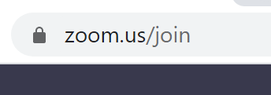
Where you will see:
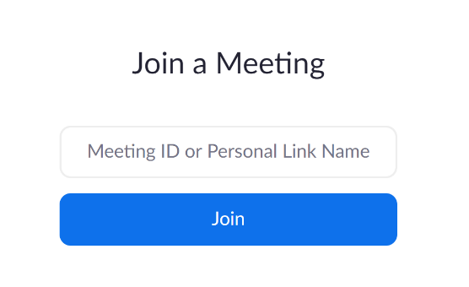
Enter the Meeting ID which will have been sent to you.
If asked, select ‘Open Zoom Meetings’, or ‘Zoom Launcher’
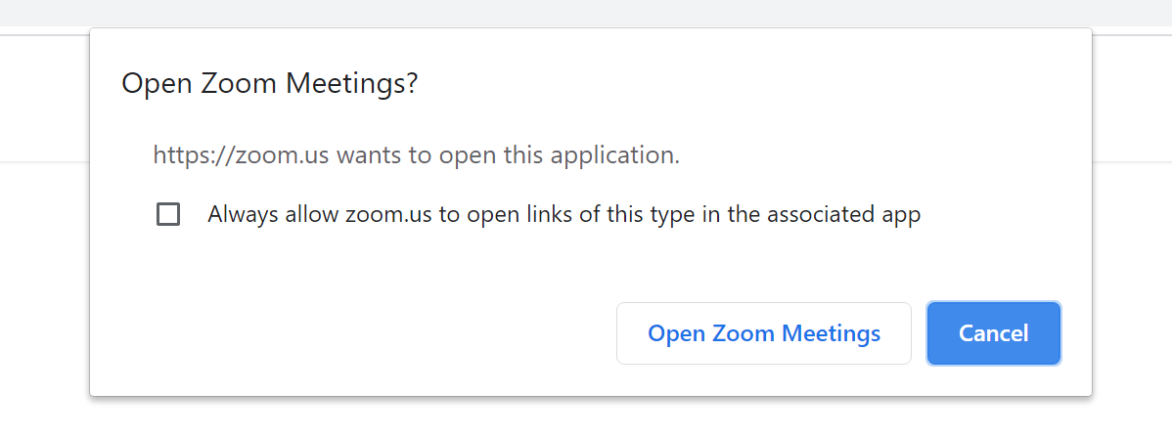
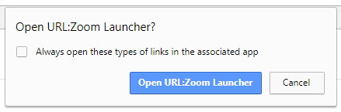

Then enter your first name and surname as it would be known to CASEE, and then the password on the next screen:

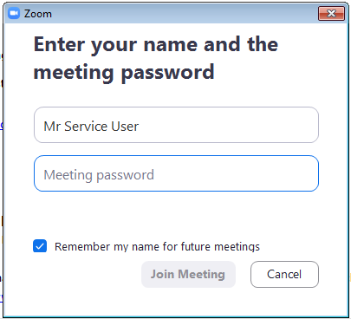

Once you choose ‘Join Meeting’, you may see:
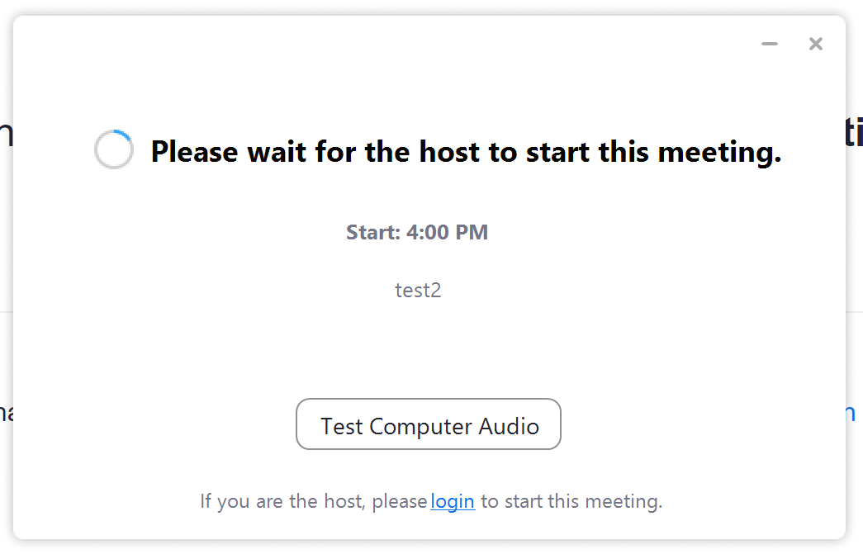
You may be given an opportunity to test your audio equipment. It is a good idea to do this before you enter the meeting.

Here you can test your speaker and your microphone.
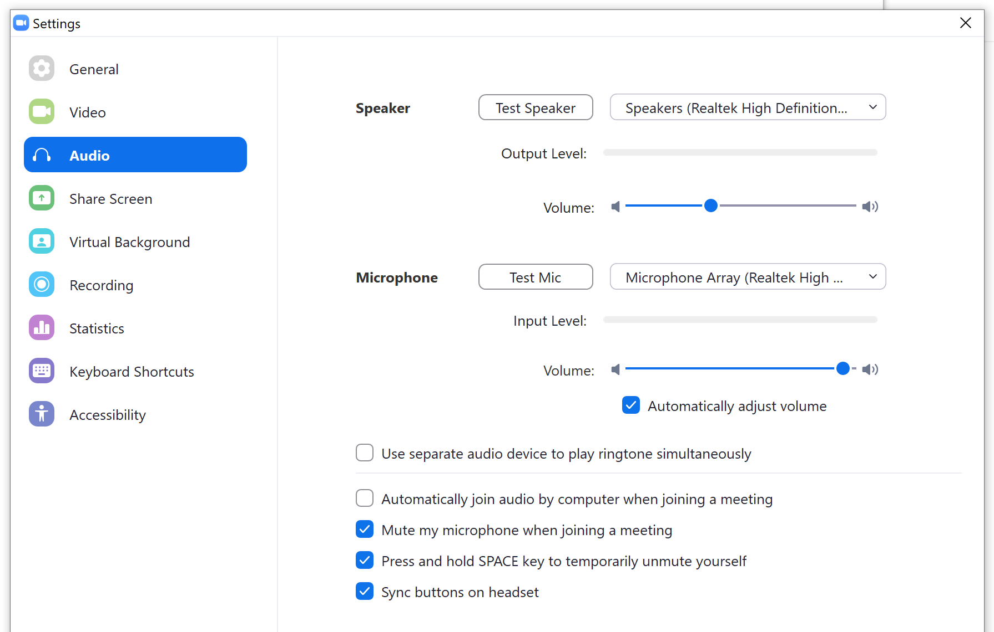

CASEE will start the meeting, or if it has already started, you will go into a Waiting Room, where CASEE can then pull you through.
When you enter the Zoom meeting, please also check that your video and microphone is not muted. Simply touch the icons to toggle on and off.
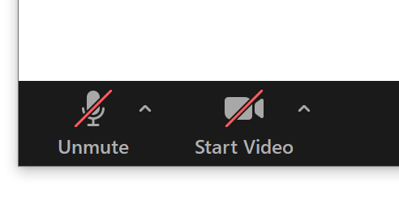
If you already have Zoom:
Open Zoom and Join the Meeting, by entering the Meeting ID and password in the usual way.
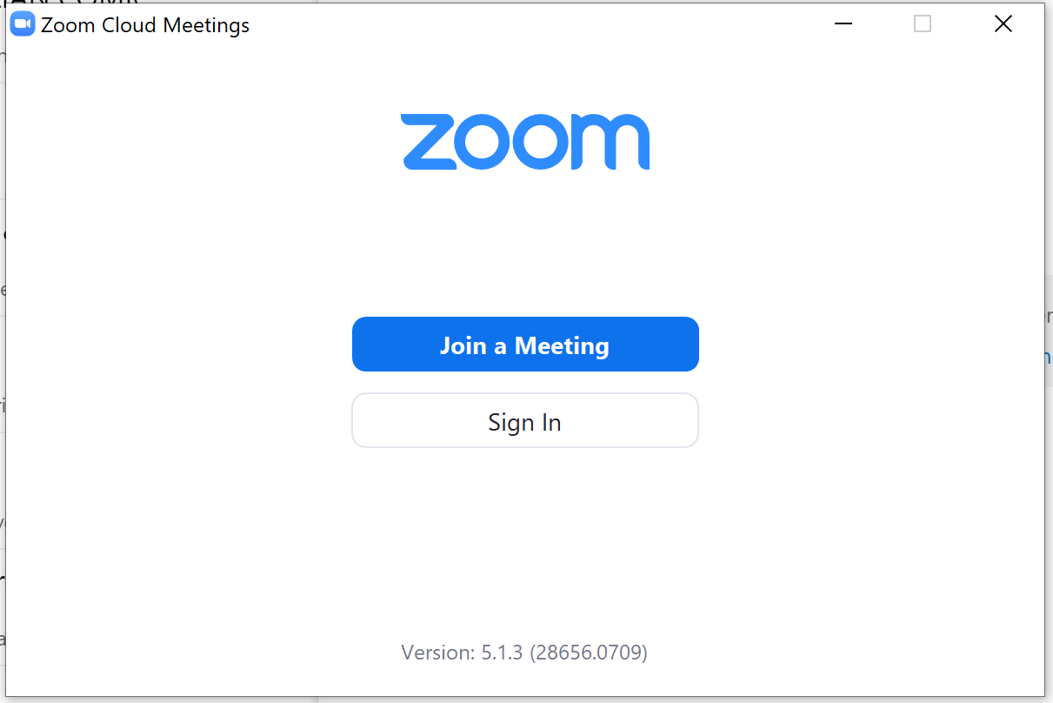
The following screens will be the same as those detailed above.

