CASEE

Communication Aid Service East of England

Providing an Augmentative and Alternative Communication Service to the East of England

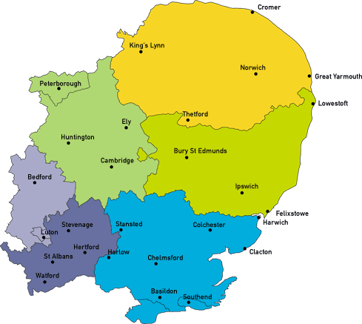

CASEE
Box 177 Cambridge University Hospitals
NHS Foundation trust Hills Road Cambridge
CB2 0QQ

Phone: 01223 349 401
E-mail Admin: enquiries.casee@nhs.net
CASEE has been commissioned to provide equitable specialist services for children and adults with complex communication needs who live in the East of England.
We aim to assess and provide Augmentative and Alternative Communication (AAC) solutions (for example electronic communi- cation aids with voice output for people without speech) for peo- ple that meet the criteria for assessment by a specialised com- munication hub and to support the establishment, training and development of local AAC services.
Please see the decision chart overleaf re: referral criteria.

We accept referrals from local therapy teams. Local Services should be involved to provide on-going support. Please contact us to discuss referral criteria or to request a referral form.

Decision chart: Guidance on referral criteria for specialised AAC services
Start here
The person currently does not meet the eligibility criteria for
No
1. Does the person understand cause and effec t ?
Yes
2. Do they understand the purpose of a communication aid ? |  | No
 |  | r
Yes
3. Is there a clear discrepancy between the person's levelof understanding and their abilityto speak?  {See note on rapidlydegenerative conditions below) |  | No .-
Yes
4. Ha ve 'low-tech' st rategies and techniques been tried or considered and are there identified reasons why such met hods are insufficientt o mee t the  person's communication needs? |  | No .  r
Yes

.- co mplex AAC assessmen t.

Please note, this does not necessar ilymean that the person shou ld not have acoess to AAC or other technology. It simply means that they are not suitable for assessmen t and
provision under this se rvice spe cifica tion at this time. Other
support and funding streams may be more suitable.

The local team shou ld explore use of lowtech strategies and techniques. Should reasons be identified as to why such
methods are insufficientt o mee t the person's
communication needs, consider re-referra l..

IV
5 . How is the person likely to use high tech or lowtech AAC in terms of languagecompe tence?

Sa. Unlikely to be able to combine words, phrases or symbols to create more than one concept.
-
-
Uses high tech aids or low tech systems to se lect one concept at a
time.

.,
Sb. Likely to use complex multi- pagevocabulary to combine multiple words, phrases or
symbols to compile a se ntence.
Sc. li kelyto be able to construct novel messages usingthe alphabet.
- -

6a. Can the person se lect items on a touch screen or keyboard with at least one hand with sufficient speed and endurance to meet their reasonab le communication needs, bearing in mind their levelof languagecompetence.
6c. Can the person se lect items on a touch screen or keyboard with at least one hand with sufficient speed and endurance to mee t their reasonab le communication needs. {See note on rapidlydegenerative conditions below).

Yes No
,, "
Nee ds should be met by Local assessment. Loca l fund ing of an y required equipment
No
,, "
Yes
,,

Likelyto need Specialised Assessment.
Nee ds should be met by Local assessment. Loca lfunding of any required equipment
NHSE funding of an y required AACequipment

NOTE: Peop le with rapidly degenerative conditions can be referred before they mee t all the criteria above, particularly in terms of speech and hand function (boxes3 and 6c). The referrer and specialised AAC se rvice team shou ld be satisfied that they are deteriorating at a rate mean ing that they are likelyto mee t the criteria within the time a communication aid would be provided. Although this time varies a period of 18 wee ks is sugges ted. It is recognised that this is a difficult determination to make, but evidence of how a person has deteriorated prior to the referral should be considered. Decisions will be made on individual clinical circumsta nces.

Specialised AACse rvice referra ldecision chart. V4.1 . August 2015.

