Postnatal Referral – please complete ALL the information
Referring Hospital: |  |  |  |  |  |  |  |  |  |  |  | Click or tap here to enter text.
Full Name & Designation of Referrer: |  |  |  |  |  |  |  |  |  |  |  | Click or tap here to enter text.
Date and Time of referral: |  |  |  |  |  |  |  |  |  |  |  | Click or tap here to enter text.
Contact details (Please include direct line number): |  |  |  |  |  |  |  |  |  |  |  | Click or tap here to enter text.
Baby Information
Baby’s name: |  |  | Click or tap here to enter text. |  |  |  |  |  |  |  |  |  |  |  |  | DOB: |  |  |  | Click or tap here to enter text. |  |  |  |  |  |  |  |  | Time of birth: |  |  |  | Click or tap here to enter text.
SEX: | MALE☐ |  |  |  |  | FEMALE☐ |  |  |  |  |  |  |  |  | Gestation: |  |  |  |  | Click or tap here to enter text. |  |  |  |  |  |  |  | EDD: |  |  | Click or tap here to enter text.
NHS. No: |  |  |  | Click or tap here to enter text. |  |  |  |  |  |  |  | Hospital Number (local): |  |  |  |  |  |  |  |  |  |  | Click or tap here to enter text.
Type of Birth: |  |  |  | Click or tap here to enter text. |  |  |  |  |  |  |  | Birth Weight: |  |  |  |  |  |  | Click or tap here to enter text. |  |  |  |  |  |  | HC: |  |  |  | Click or tap here to enter text.
Cleft Diagnosis: See photos for reference |  |  |  |  |  |  |  |  |  |  |  | Click or tap here to enter text.
Date of Diagnosis: |  |  |  | Click or tap here to enter text. |  |  |  |  |  |  |  |  |  |  |  |  |  |  |  |  |  | Time of Diagnosis: |  |  |  |  |  |  |  | Click or tap here to enter text.
APGAR SCORES [choose from the drop down.] |  |  |  | ?? @ 1 Mins |  |  |  |  |  |  |  |  |  |  |  | ?? @ 5 Mins |  |  |  |  |  |  |  |  |  |  | ?? @ 10 Mins
Other medical conditions: Please include any suspected anomalies, breathing concerns etc.
Click or tap here to enter text.

Micrognathia: |  |  |  |  |  |  |  | YES☐ |  |  |  |  | NO ☐ |  |  |  |  | Glosoptossis: |  |  |  |  |  |  |  |  |  |  |  | YES☐ |  |  |  | NO ☐
Baby’s current location: |  |  |  | Labour Unit ☐ |  |  |  |  |  |  | Postnatal ☐ |  |  |  |  |  | NICU ☐ |  |  |  |  |  |  | Special Care ☐ |  |  |  |  |  |  |  | Home ☐
Other Please specify: |  |  |  |  |  | Click or tap here to enter text.
NIPE completed: |  |  |  |  | YES ☐ |  |  |  |  | NO ☐ |  |  |  |  |  | Ethnicity: |  |  |  |  |  |  |  |  | Click or tap here to enter text.
Interpreter required: |  |  |  |  | YES☐ |  |  |  |  | NO ☐ |  |  |  |  |  | Language spoken: |  |  |  |  |  |  |  |  | Click or tap here to enter text.
Known to Social care: |  |  |  |  | YES ☐ |  |  |  |  | NO ☐ |  |  |  |  |  | Social Workers Name: |  |  |  |  |  |  |  |  | Click or tap here to enter text.
Social Workers Contact Telephone no. |  |  |  |  |  |  |  |  |  |  |  | Click or tap here to enter text.
Contact information
Mothers Name: |  |  |  | Click or tap here to enter text. |  |  |  |  |  |  |  |  |  |  |  |  |  |  |  |  |  | Mother DOB: |  |  |  |  |  |  |  | Click or tap here to enter text.
Home Address: |  |  |  | Click or tap here to enter text.
Contact telephone no. |  |  |  | Home |  |  |  |  | Click or tap here to enter text. |  |  |  |  |  |  |  |  |  |  |  | Mobile |  |  |  |  |  | Click or tap here to enter text.
GP: Name: |  | Click or tap here to enter text. |  |  |  |  | GP: Address: |  |  |  |  |  |  | Click or tap here to enter text. |  |  |  |  |  |  |  |  |  |  |  |  |  |  |  | Post code:  Click or tap here to enter text.
Thank You! Please send your completed referral to add-tr.Cleftref@nhs.net
Please call the cleft office on 01223 596272 (Option 1) - To notify the office there is a referral

Diagnosis
Please indicate with a tick the most appropriate diagnosis (you may need to tick more than one):

☐ | Cleft lip +/- alveolus | ☐ | Unilateral Cleft lip & palate |  |  | ☐ | Bilateral cleft lip & palate
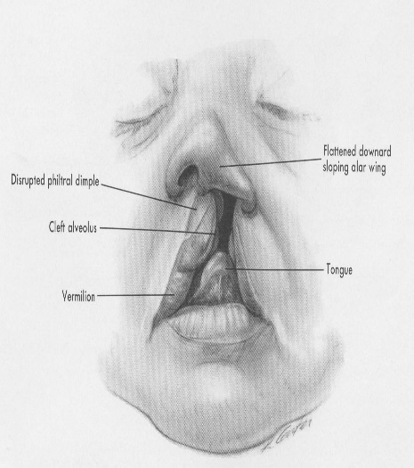 |  | 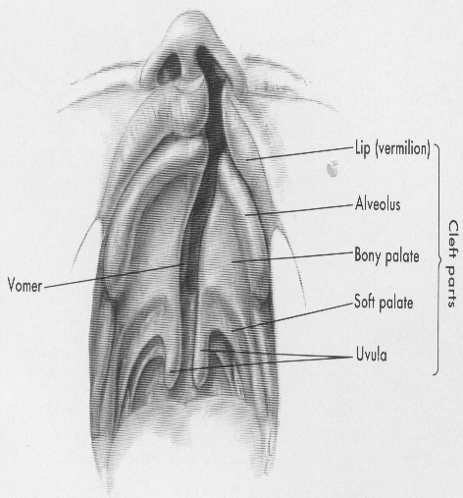 |  |  |  | 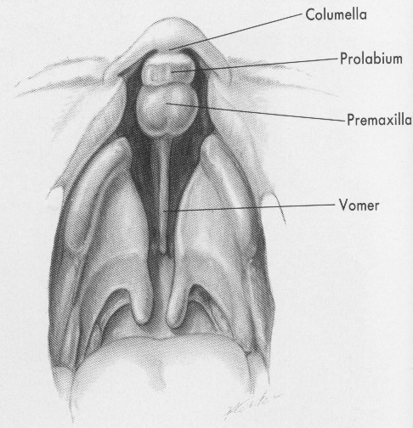
☐ | Micrognathia |  |  | ☐ | Cleft of hard and soft palate
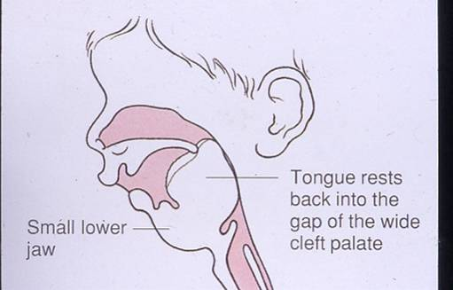 |  |  |  | 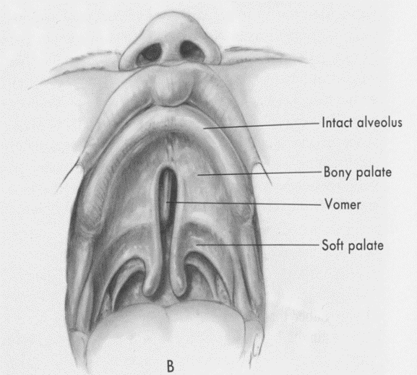
☐ | Cleft of soft palate |  |  | ☐ | Submucous Cleft palate
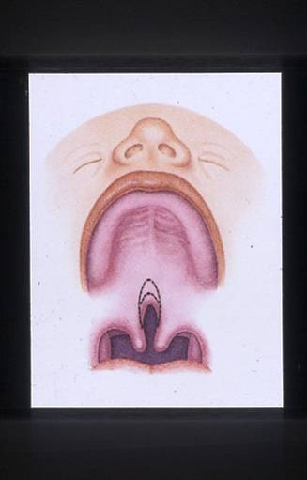 |  |  |  | 